Server less

<https://jamstack.org/examples/>

<https://thepowerofserverless.info>

Video tutorial:

<https://www.freecodecamp.org/news/beaucarnes/all-powerful-front-end-developer--i9ZVp2312>

GitHub

CODEPEN

Netlify

# user login - <https://auth0.com>

# Run script - <https://webtask.io/> . (video 9’00’’ – 11’30’’)

* Wrap personal api

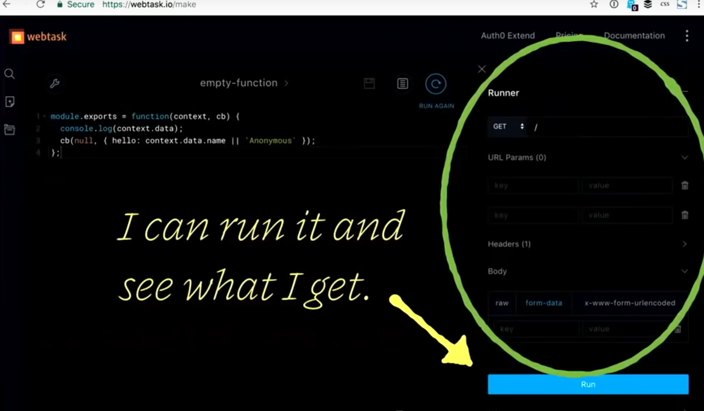

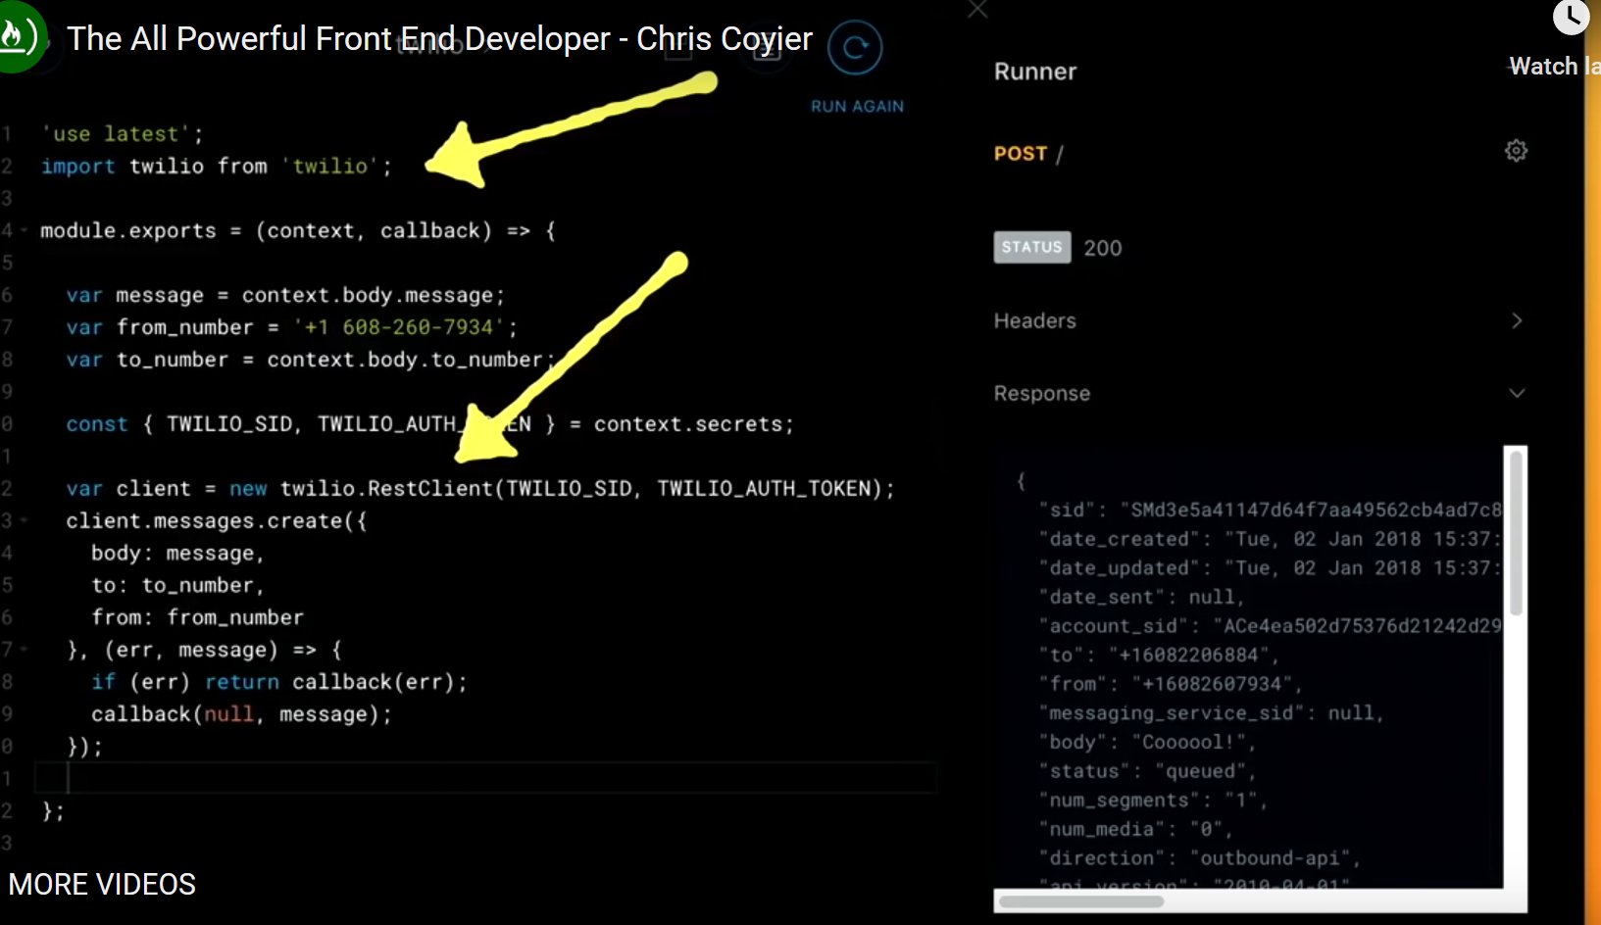

# Use form in the site

* Formkeep.com
* Pageclip.co
* Netlify.com
* Formcarry
* useBasin.com

# database

* Airtable

# Payments

# Display

* gohugo.io
* Gatsby --------------------------!
* Hexco
* Metalsmith
* jekyllrb
* Middleman
* 11ty.io

# monitor server site function

- circleci.com

# Notify

## Send emails

* Sparkpost
* Mailgun
* sendGrid – send password resets

# other

<https://firebase.google.com/>

<https://slack.com>

-类似机器人，聊天窗口，可以通过聊天做很多事情，也可以用聊天窗口当作提醒。

